

ASSIGNMENT 1

PROGRAMMING TECHNIQUE I

(SECJ1013)

|  |  |
| --- | --- |
| NAME | MATRIC NUMBER |
| MUHAMMAD AFIQ DANIAL BIN ROZAIDIE | A23CS0117 |
| MOHAMED ALIF FATHI BIN ABDUL LATIF | A23CS0112 |

Lecturer: Dr. Nies Hui Wen

SET 1

1. Start

2. Read name1, matric1, name2, matric2

3. display “Assignment 1”

4. display “Course: SECJ 1013 Programming Technique 1”

5. display “Section 03”

6. display “Program: Bachelor of Computer Science (Data Engineering)”

7. display “Member”

8. display name1, “(“, matric1, “)”

9. display name2, “(“, matric2, “)”

10. End

# include <iostream>

using namespace std;

int main(){

string name1, name2, matric1, matric2;

cout << "Enter member 1 name: ";

cin >> name1;

cout << "Enter member 1 matric number: ";

cin >> matric1;

cout << "Enter member 2 name: ";

cin >> name2;

cout << "Enter member 2 matric number: ";

cin >> matric2;

cout << "\nAssignment 1\n-----------------\nCourse: SECJ 1013 Programming Technique 1" << endl;

cout << "Section: 03\nProgram: Bachelor of Computer Science(Data Engineering)" << endl;

cout << "Member:\n" << name1 << " (" << matric1 << ")" << endl;

cout << name2 << " (" << matric2 << ")" << endl;

return 0;

}

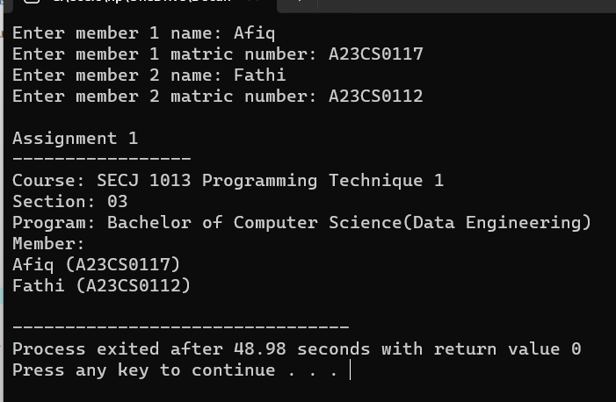OUTPUT:

SET 4

# include <iostream>

using namespace std;

int main (){

double price;

int quantity;

string level;

price = 0;

cout << "Enter the quantity and level: ";

cin >> quantity >> level;

if (level == "Low"){

if (quantity >= 0 && quantity < 15)

price = quantity * 0.3;

else if (quantity >= 15 && quantity <= 50)

price = quantity * 0.5;

else if (quantity >= 51)

price = quantity * 0.7;}

else{

if (quantity > 0 && quantity <= 10)

price = quantity * 0.2;

else if (quantity > 10 && quantity <= 20)

price = quantity * 0.3;

else if (quantity > 20)

price = quantity * 0.6;}

cout << "Price: RM " << price ;

return 0;

}

OUTPUT 1:

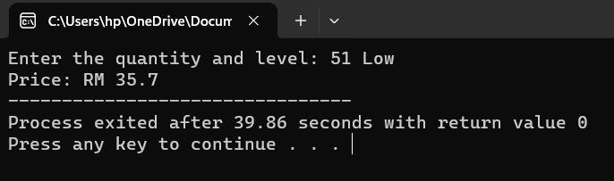

OUTPUT 2:

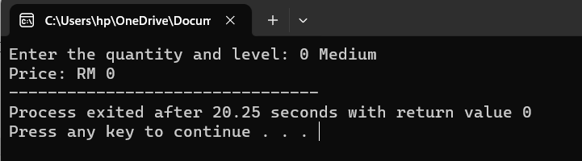

OUTPUT 3:

